BUILDING BUS RESERVATION SYSTEM

NAME: RUBA.S

COLLEGE NAME: ANNAI MATHAMMAL SHEELA ENGINEERING COLLEGE

REG NO: 620221104026 COLLEGE CODE:6202

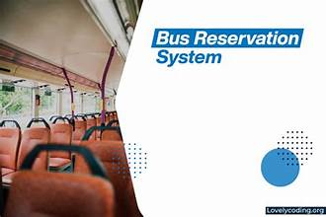

ABSTRACT

Online Bus Ticket Reservation System is a web-based application that works within a file. one network. This project introduces an update to the software program “Online Bus Ticket Reservation System ”as it should be used in the bus system, the area used reserved seats, booking cancellations and various types of route inquiries used for security quick booking. OBTRS is designed to manage and compile a traditional database, ticket booking and bus tracking and departure made. Maintains all customer details, bus details, booking details. In order to achieve the design, Imo Transport Company (ITC) was selected as case study because of its importance in Imo State strategies. Systematic Analysis once Design Methodology (SSADM) was approved. In addition, PHP Hypertext Preprocessor (PHP) language was used for software terminals while the back end was designed for use MySQL. Achieved software is able to improve customer support and relationships ITC performance management. It is recommended that in addition to the current operation of the file customized software, additional functionality such as using email to send tickets again customer notifications and online payments using credit / bank cards should be the same installed in the system. In addition, other functions performed by ITC such as courier services must also be integrated to improve the system.

Keywords: OBTRS, Electronic Ticketing, ITC, Reservation, Transportation

PROBLEM STATEMENT

System that are using by the staff at the counter currently is an internal system and just used to sell the bus ticket at the counter. Customer has to go to the counter to buy bus ticket or ask for bus schedule. Furthermore, customers need to pay cash when they buy the bus ticket and sometimes needs to queue up long time to get the bus ticket. Besides that, customer also not allowed to buy bus ticket through telephone and the bus company’s telephone always-busy line.

PROJECT OVERVIEW

A project overview statement is a document that includes a brief description of the project, its rationale and objectives, and its expected outcomes. It is a summary of the work and what is expected.

A project overview statement should be clear and concise, providing just enough information to give key stakeholders a general idea of what the project is about and why it is important without getting into too much detail.

The purpose of an overview statement is to get everyone on the same page about the basics of the project before more detailed planning begins.

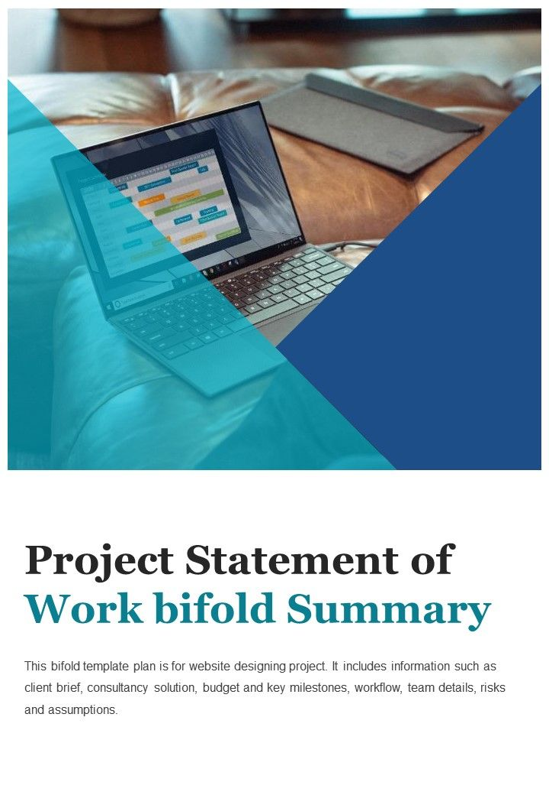TECHNOLOGY VIEW

The technology vision statement is a compelling, succinct statement that has been created with input and approval from all members of your technology team. The statement should reflect the interests of your various stakeholders and paint the picture of how your library will function with the mission-driven use of technology.

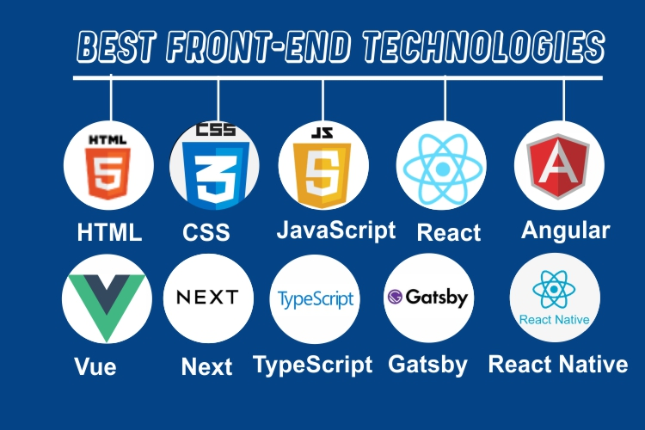





MODELING & RESULT

 Bus reservation system modeling & result

The system of collecting data for research project is known as research methodology. The data may be collected for either theoretical or practical research for example management research may be strategically conceptualized along with operational planning oral interview. method and change management. Information which was used for this study was carried out byoral interview.

RESULT

Research and development are continuous processes; this is the same in computer and software development. However, this work is recommended for Imo Transport Company Limited, Owerri, since their operation are still carried out manually and it can also be useful to other Bus Transportation industries whose processes are still manually done.

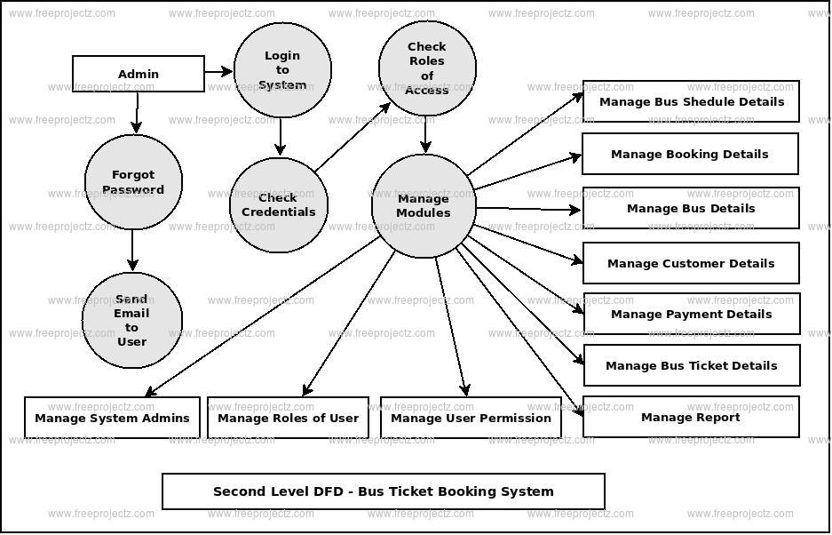

SCREEEN SHOT

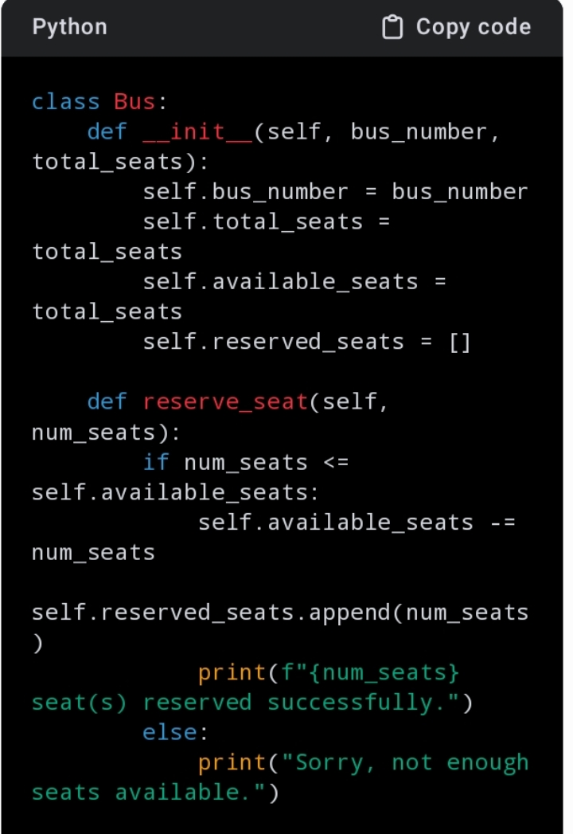

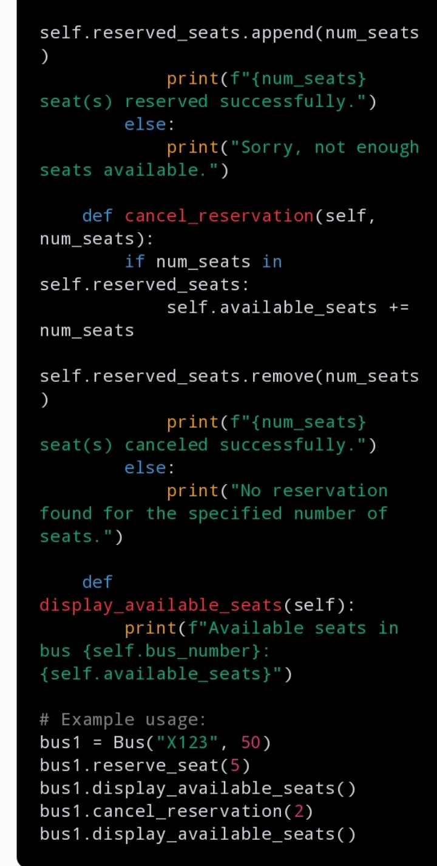

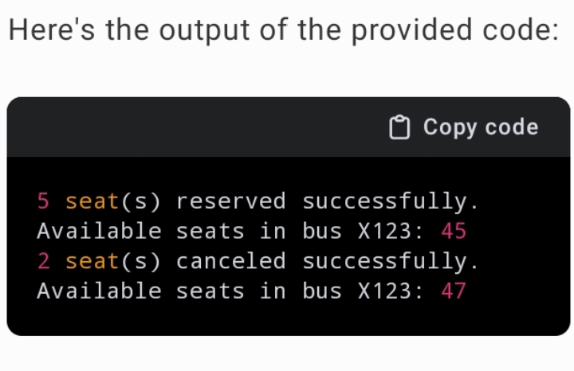

**FUTURE ENHANCEMENT**

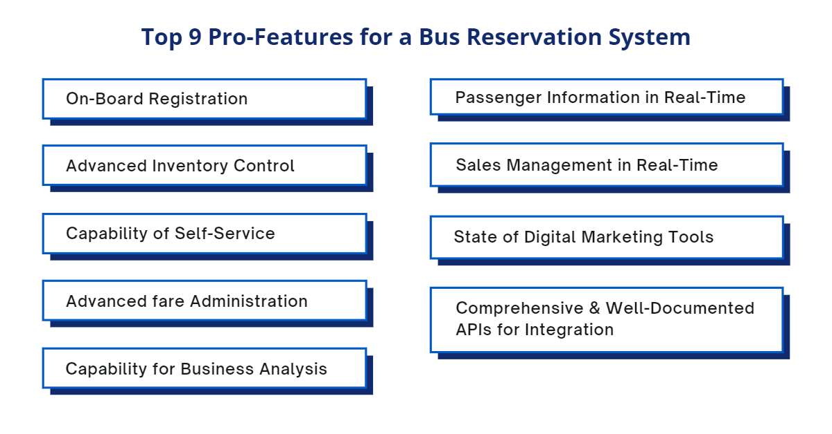

**CONCLUSION**

It can be observed that computer applications are very important in every field of human endeavor. Here all the information about customer that made reservation can be gotten just by clicking a button system, with this new some of the

difficulties encountered with the manual system are overcome. It will also reduce the workload of the staff, reduce the time used for making reservation at the bus terminal and also increase efficiency. The application also has the ability to update records in various files automatically thereby relieving the company’s staff the stress of working from file security of data.

**THANK YOU**